**DUTCH HOLLOW CC**

**LADIES GOLF ACADEMY 2015-NOVICE GROUP**

**Week 5**

**Pitching and Chipping**

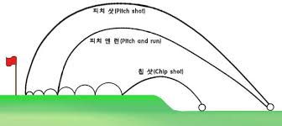

**\*Pitching=Higher ball trajectory, less roll out.**

**\*Chipping=Lower ball trajectory, more roll out.**

**\*To hit the ball higher, finish with your hands higher.**

**\*To make the ball go lower, finish with your hands lower.**

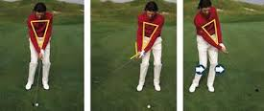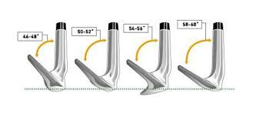

**Different lofts on wedges.**

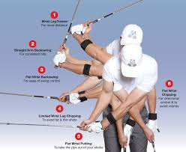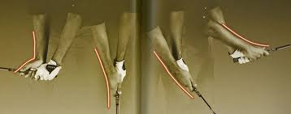

**How the forearms rotate through impact toward the follow through.**

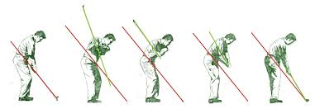

**Bunker**

Notice the shaft of the golf club above is on the **same plane (angle)** on the follow through as it was on the backswing. As a matter of fact, notice the shaft angle of the golf club in the first four pictures. **Same plane all the way through**.

**Sand**

**Shot**

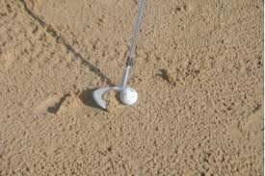 

The object in the greenside bunker is to **“splash”** the sand and the ball out of the sand trap at the same time. The easiest way is to make your club hits the sand about 1 inch behind the ball. You have to apply some force to the shot, and be sure to follow through to a good finish to make sure the ball leaves the sand trap. Throw the ball and sand out at the saame time.