**DUTCH HOLLOW CC**

**LADIES GOLF ACADEMY 2015-NOVICE GROUP**

**Week 4**

Putting is an individual art form. While there are standard grip and stroke techniques as illustrated here, getting the golf ball in the hole is a unique combination of individual preferences.

The sight and sound of a ball going over the edge of the cup and falling into the hole never gets old.

Keep it in your golf memory bank.

Visualizing the ball going into the hole before each putt can help. Learning to read greens also helps you make more putts.

You first have to understand a few things about putting. Then it is just focus on the greens practicing good techniques.

The rest is learning to repeat the fundamentals, and learning to get the ball into the hole.

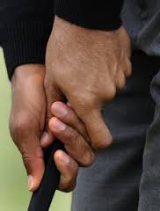 

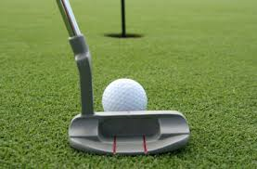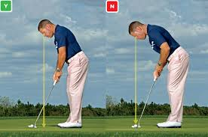

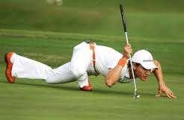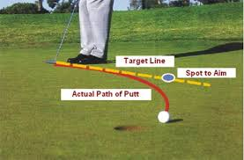

Camillo Villegas uses the “snake technique” to read the break of his putts.

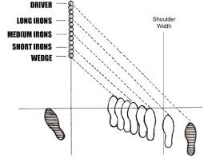

Ball Position according to Ben Hogan: Always play the ball inside the left heel for every shot. Adjust your right foot to vary the width of your stance for the different length of each club.

This gives you a “common starting point” for every golf shot. The left foot becomes your compass to orient yourself to the ball.

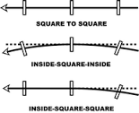 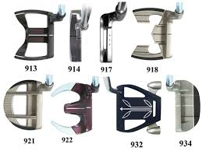

**CHIPPING**

 