**DUTCH HOLLOW CC**

**LADIES GOLF ACADEMY 2015-NOVICE GROUP**

**Week 3**

**Ball Position Setup**

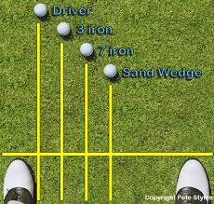 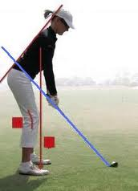 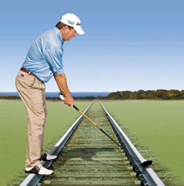

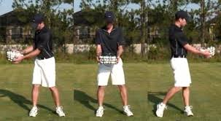

The “Core Muscles” are the engine that power any golf swing. Whether you are a Tour Pro or an amateur golfer, the core muscles must at some point figure into the golf swing equation to generate power and control of the golf club.

There is not enough power in the arms and hands alone to generate any meaningful golf swing effort.

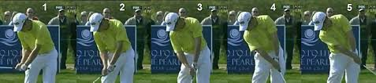

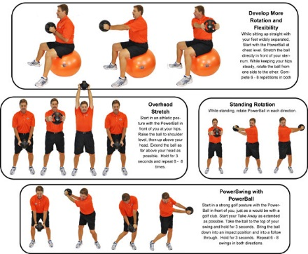 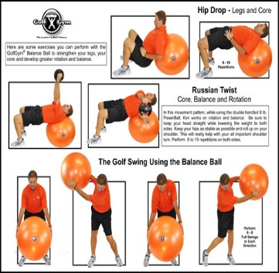 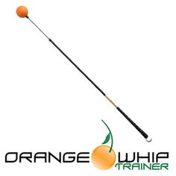

**“Early Release” Releasing the golf club too soon as shown on the left leads to the club head passing the hands through impact which leads to all kinds of bad shots.**

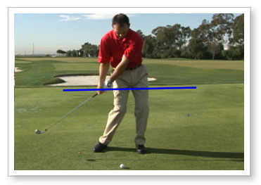 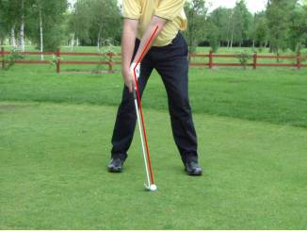

**Proper Release**

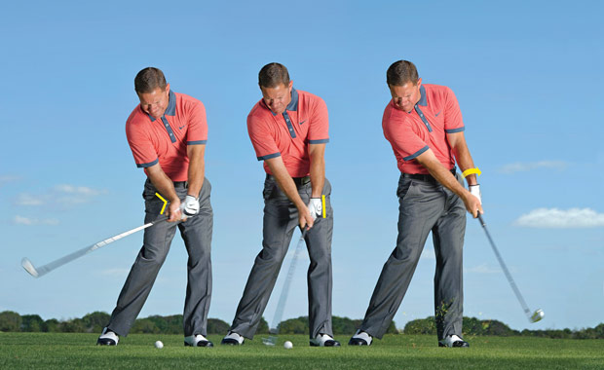

**Hold the angle of the club and arms illustrated on the far left picture, as long as you can before letting the club go through impact. Your muscles will tell you when to release the club.**