**DUTCH HOLLOW CC**

**LADIES GOLF ACADEMY 2015-NOVICE GROUP**

**Week 2**

**Ball Position Setup**

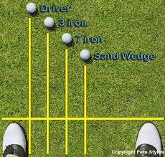 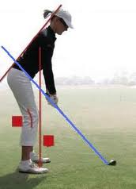 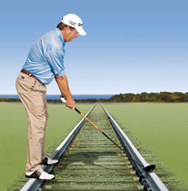

**Shoulder Turn Half Way Back**

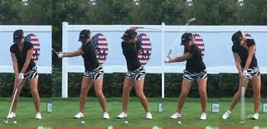 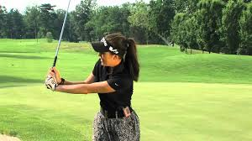

**Left**: club points down the target line at the top of the backswing. Notice the triangle between the elbows and the hands.

**Right**: Notice the triangle is still intact as the arms and club move toward the bottom of the downswing.

**Top of Backswing**

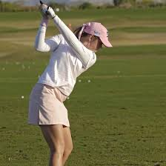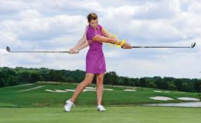

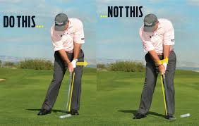

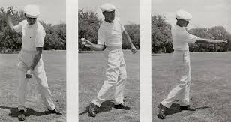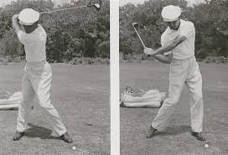

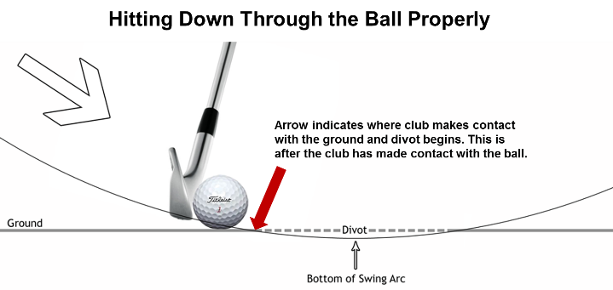 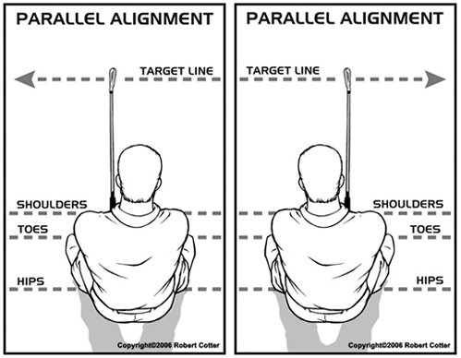

**ROLL YOUR ANKLES FOR A PROPER WEIGHT TRANSFER-Words of Wisdom from Jack Nicklaus**

When I first learned the game, Jack Grout had me go home without a golf club and just swing my arms back and through, rolling my ankles. It was brilliant. Your arms won't swing if your ankles don't roll. This is playing golf from the ground up.

As in any sport--baseball, tennis, football--your feet dominate what you do. Rolling the ankles teaches you two things: (1) to have a soft forward movement while keeping you steady on the ground, and (2) to release the club, because your right foot stays close to the ground as you swing through impact.