DUTCH HOLLOW CC
LADIES GOLF ACADEMY 2016-NOVICE GROUP
Week 1
Golf 101
1. Golf is and should always be fun. It is a time to relax, be happy, and enjoy friends.
2. Golf is the one game you can play for your lifetime. You have made a great investment.
3. Companionship, comradery, good conversation, and a good time are prerequisites to a good round of golf.
4. Solid fundamentals are the key to solid golf shots.
GRIP
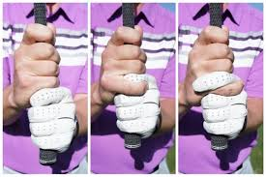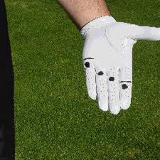
Shoulder Turn
http://www.pga.com/golf-instruction/instruction-feature/off-tee/more-powerful-swings-women-golfers-video
Swing Sequence
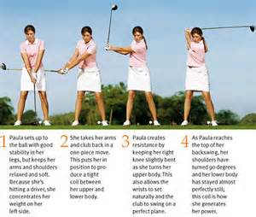
-Let the club swing freely through the ball at impact.-

14 Clubs

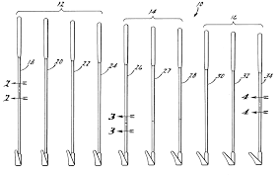
The divot is on the target side of the ball.

